# Part 0: Preparation

* Download “Activity 1 Resources” from CourseVille.

# 

# Part 1: Text Representation

* You will be using [HexEd.it](https://hexed.it/) instead of HexEdit.

1. Click “Open File” option near the top-left corner to open .txt files

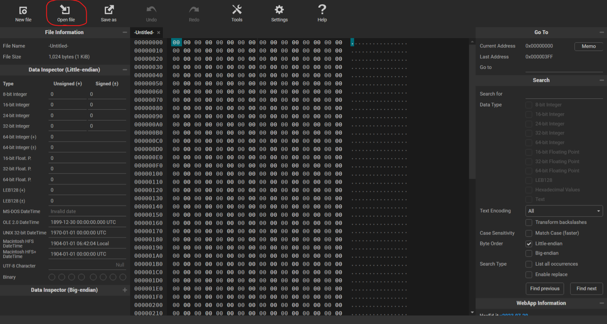

1. You can check the address in the top right-corner.

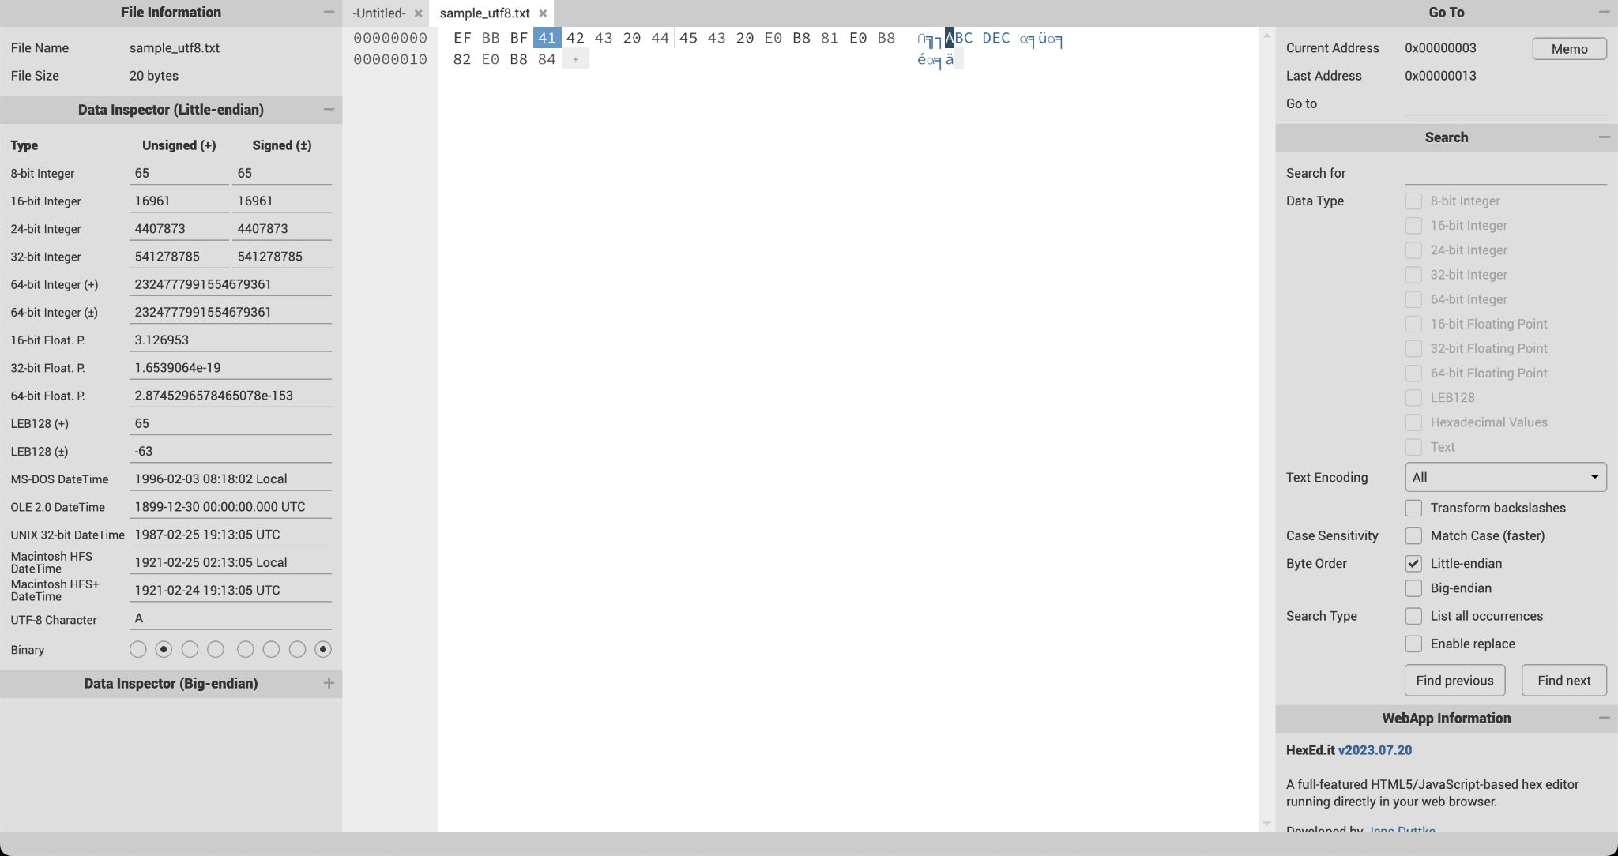

1. If you want to see the result of your edit, Click “Export” near the top-left corner and save or replace the file in your folder.

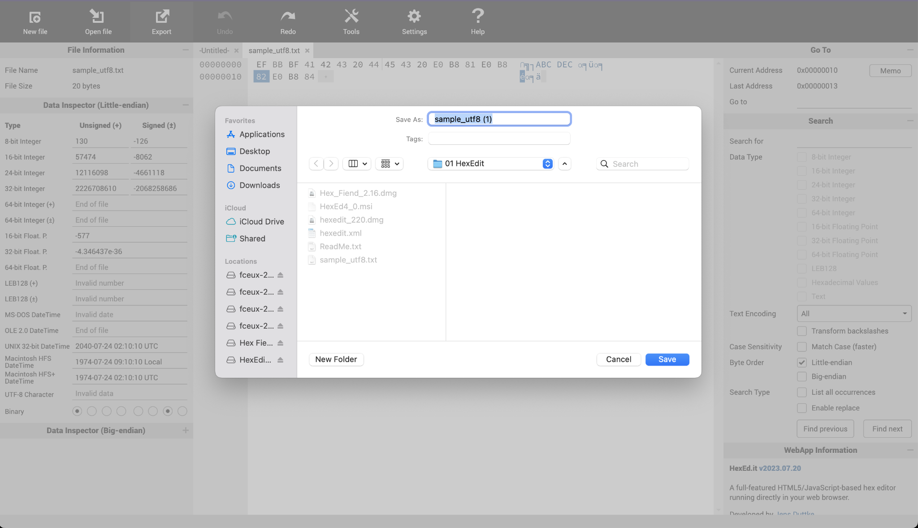

1. If you want to create a new file, Click “New File” near the top-left corner Click apply without choosing the size.

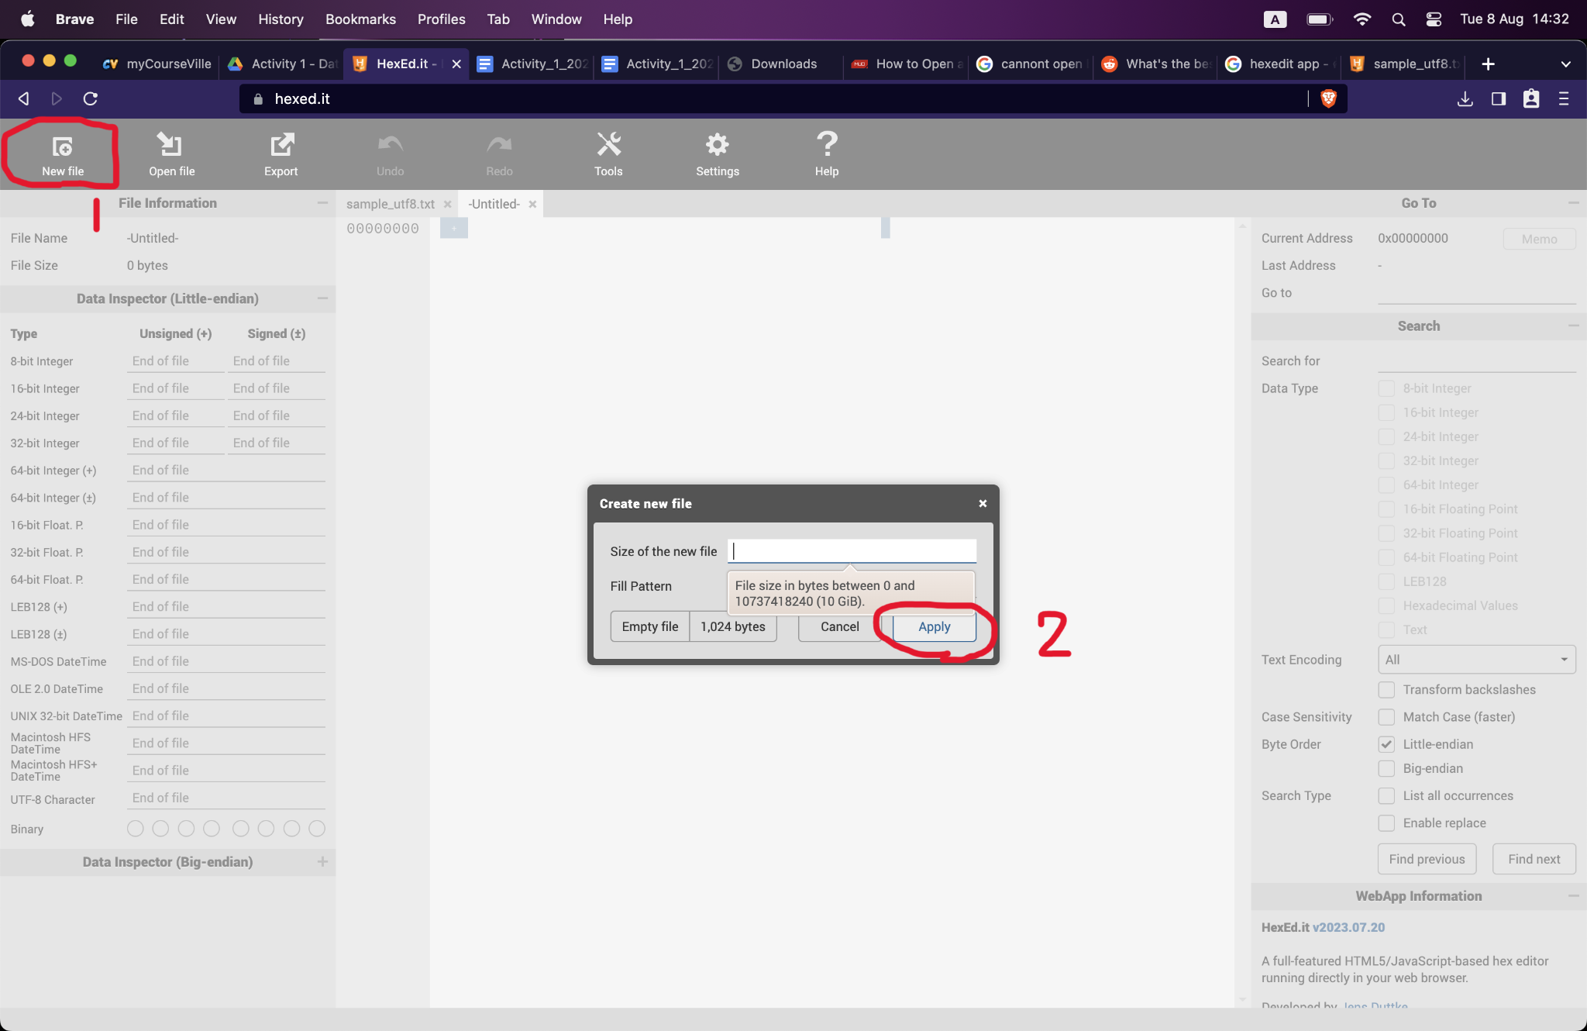

# Part 2 : Image Representation

**What is the dimension of the image, and how can you find it in HexEdit?**

Answer : You can’t find it in HexEd.it, you have to ask Windows users in your team.

**What does the content at 01C - 01D represent?**

Answer : You can’t find it in HexEd.it, you have to ask Windows users in your team.

**Part 3: Installing fceux**

1. Download “fceux-2.6.5-Darwin.dmg” from <https://github.com/TASEmulators/fceux/releases/download/v2.6.5/fceux-2.6.5-Darwin.dmg>

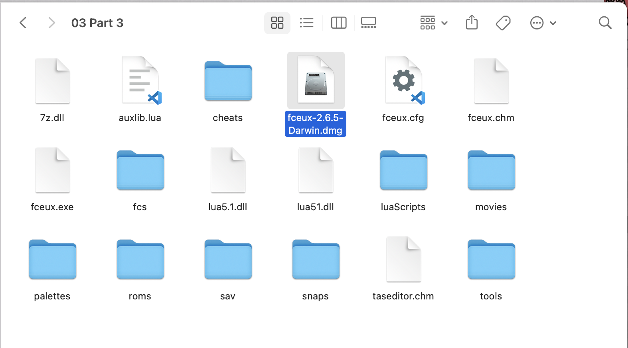

1. Hold [Control + Left Click] to open the file with DiskImageMounter as shown below.

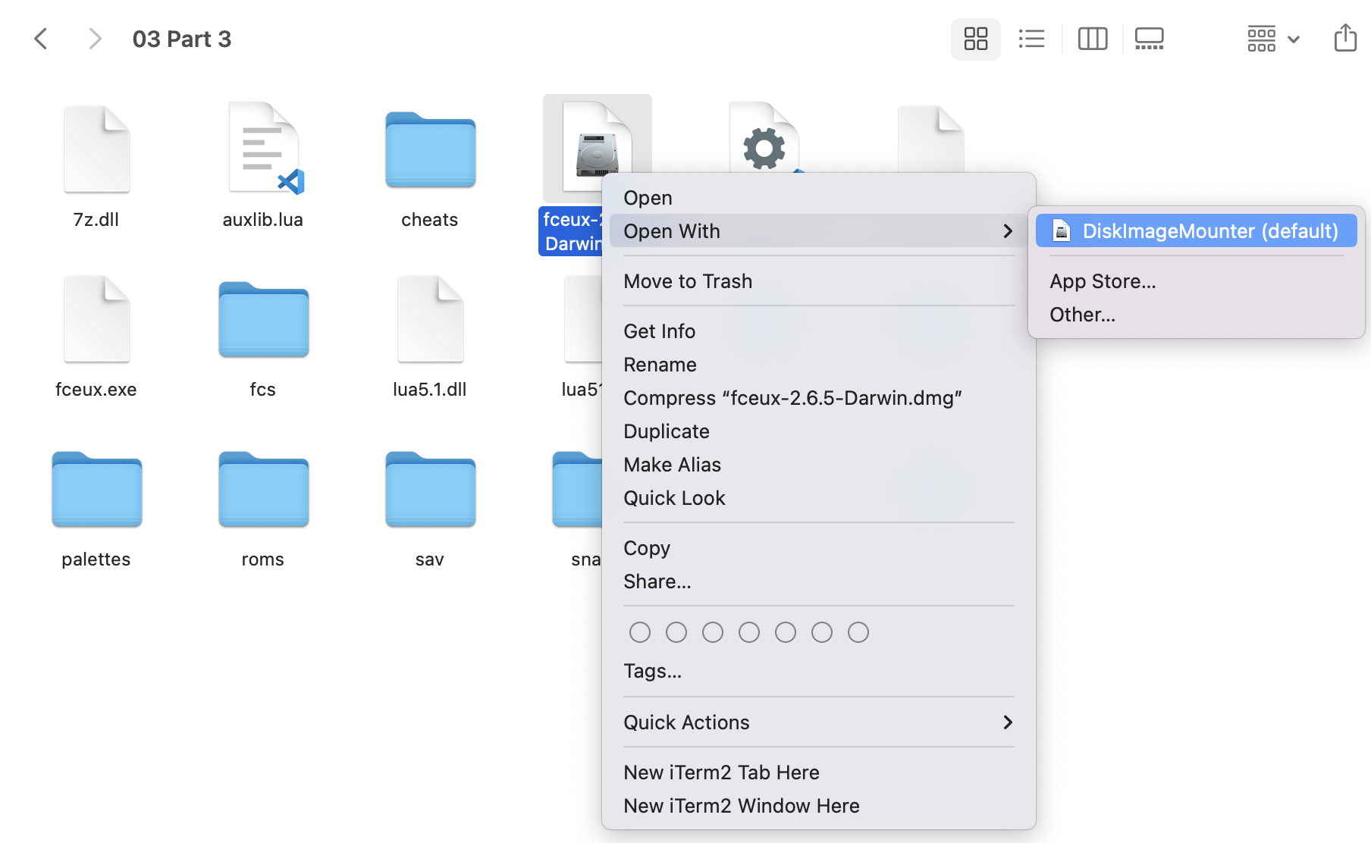

1. Drag and drop “fceux” into “applications” folder as shown below.



1. “fceux” should appear in your application folder.

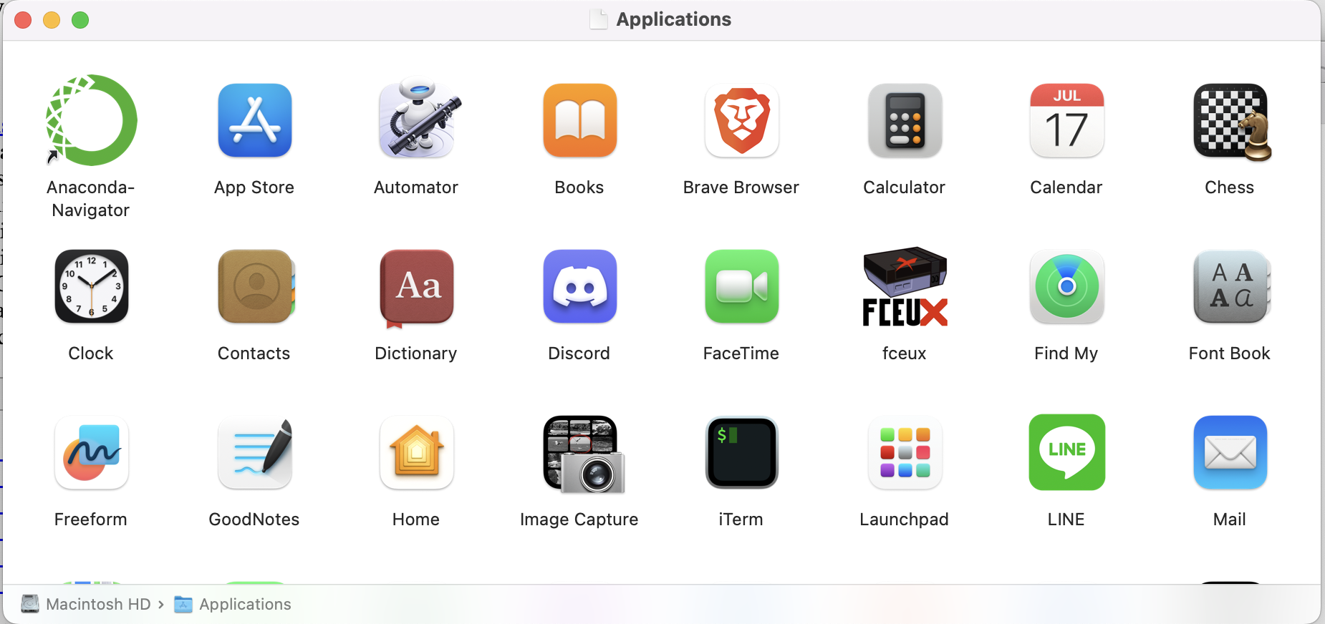

1. Hold [Control + Left Click] to open the file.

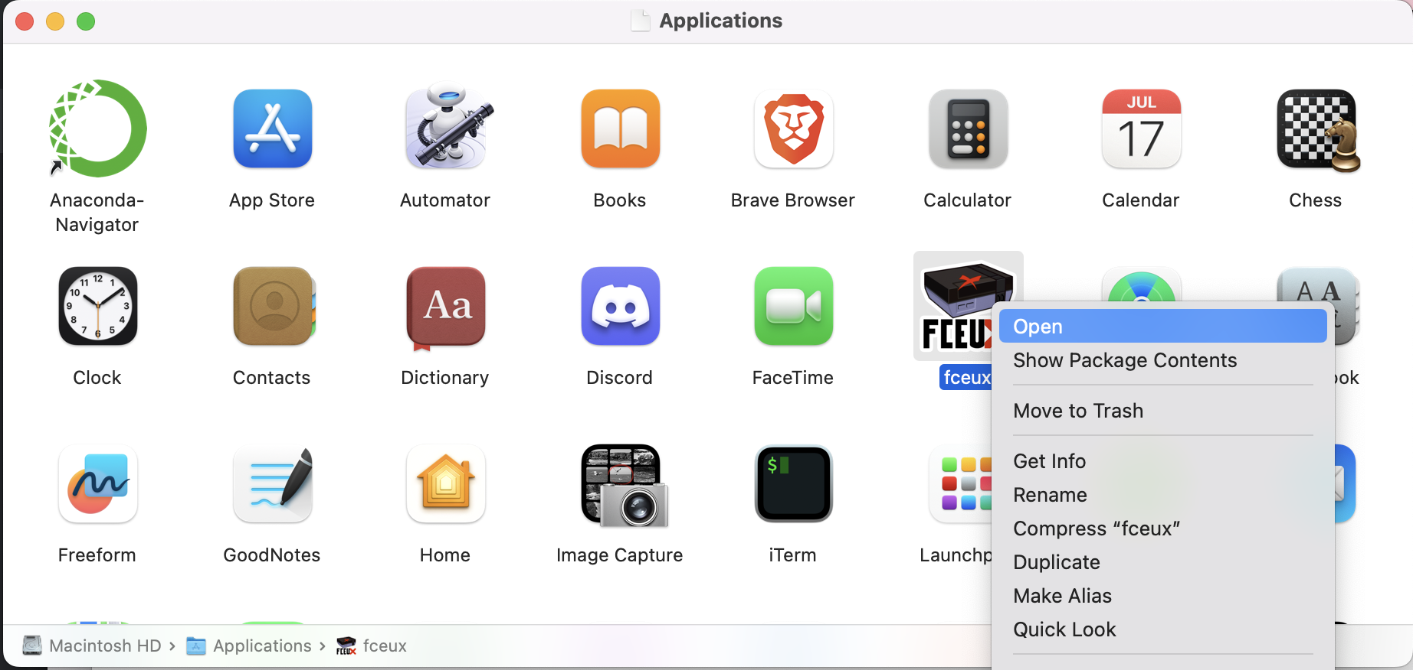

1. Click open.

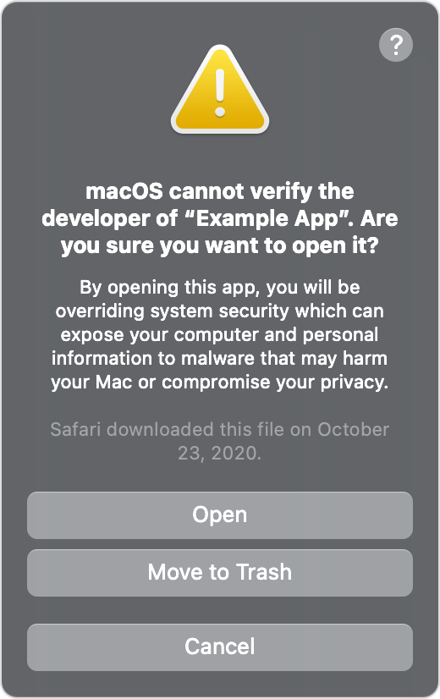

1. You should be able to follow “**Part 3: Data Representation in the Memory**” by now.